# Implementing Web Application Creating IBM-Db2 and Connect With Python

|  |  |
| --- | --- |
| Date | 27 October 2022 |
| Team ID | PNT2022TMID29836 |
| Project Name | CUSTOMER CARE REGISTRY |

**Step 1.** Creating IBM data base

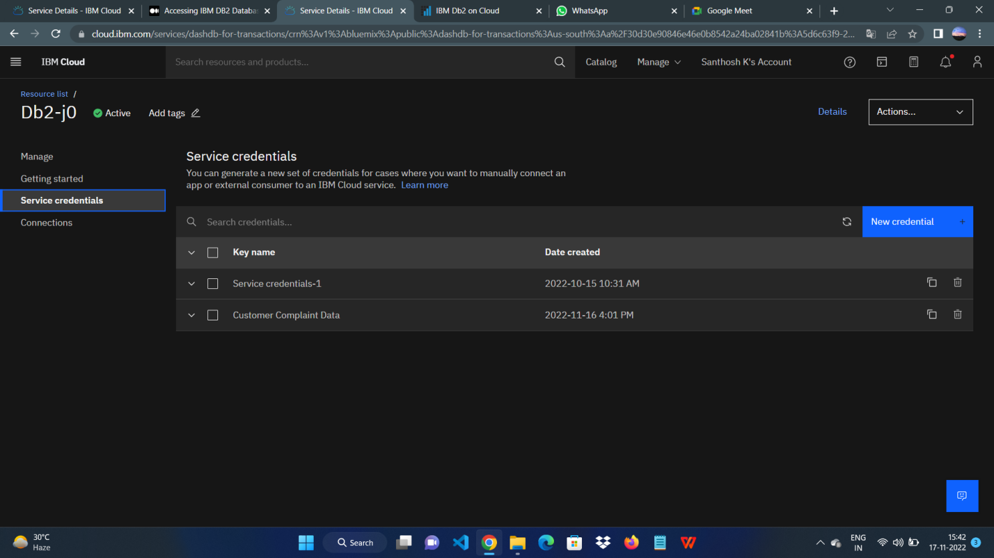

**Step 2**. Downloading SSC certificate for connection

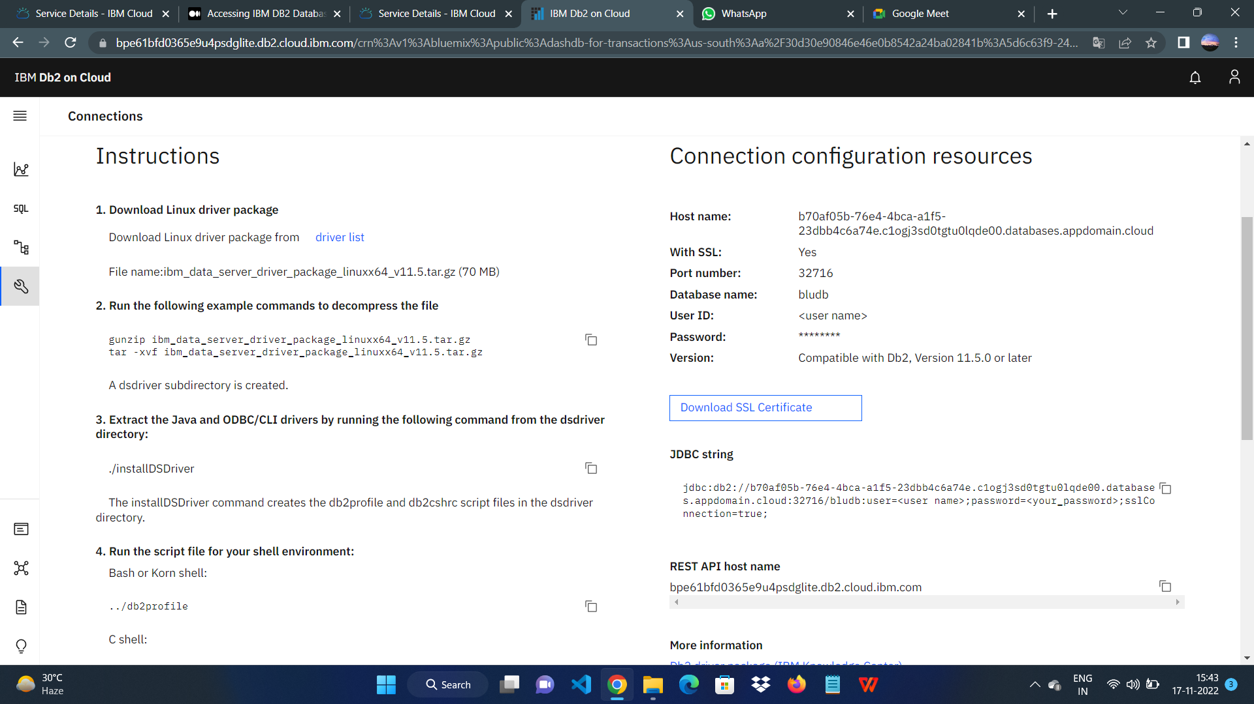

**Step 3**. Creating service credential which contains host name, DB name, UID, Password

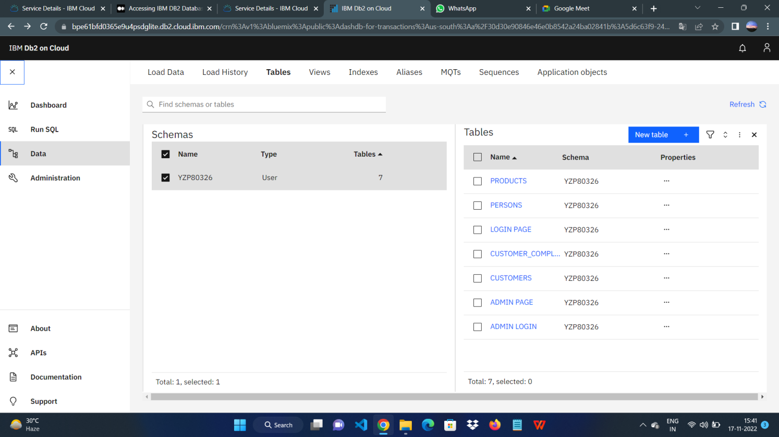

**Step 4.** Installing ibm-db package

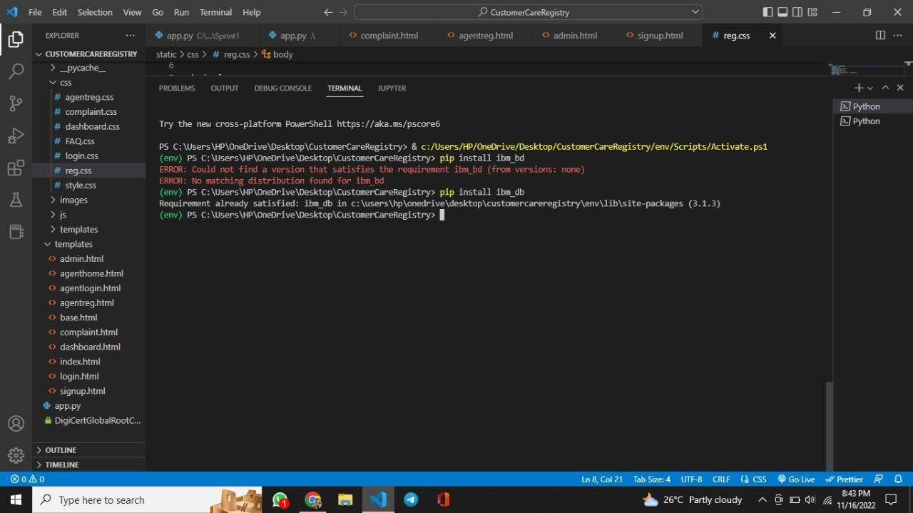

**Step 4.** Connecting IBM DB2 with python flask

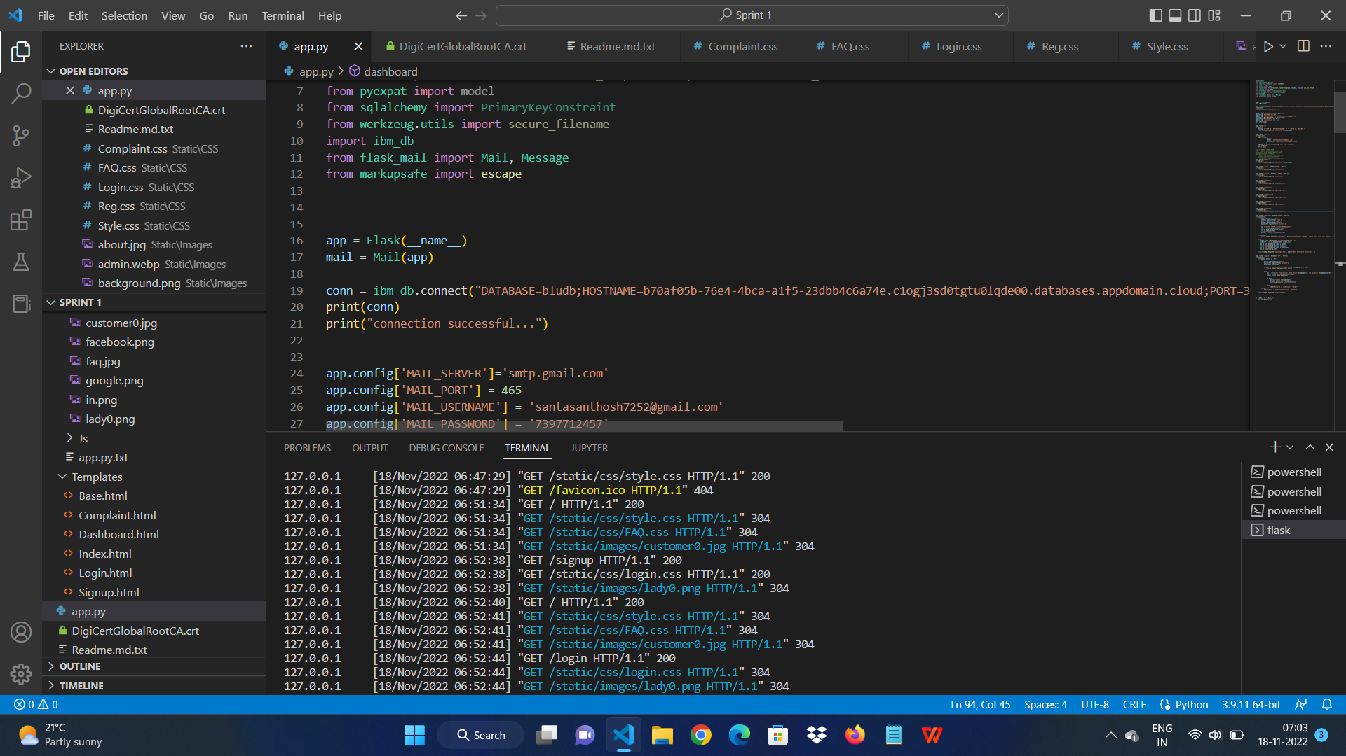

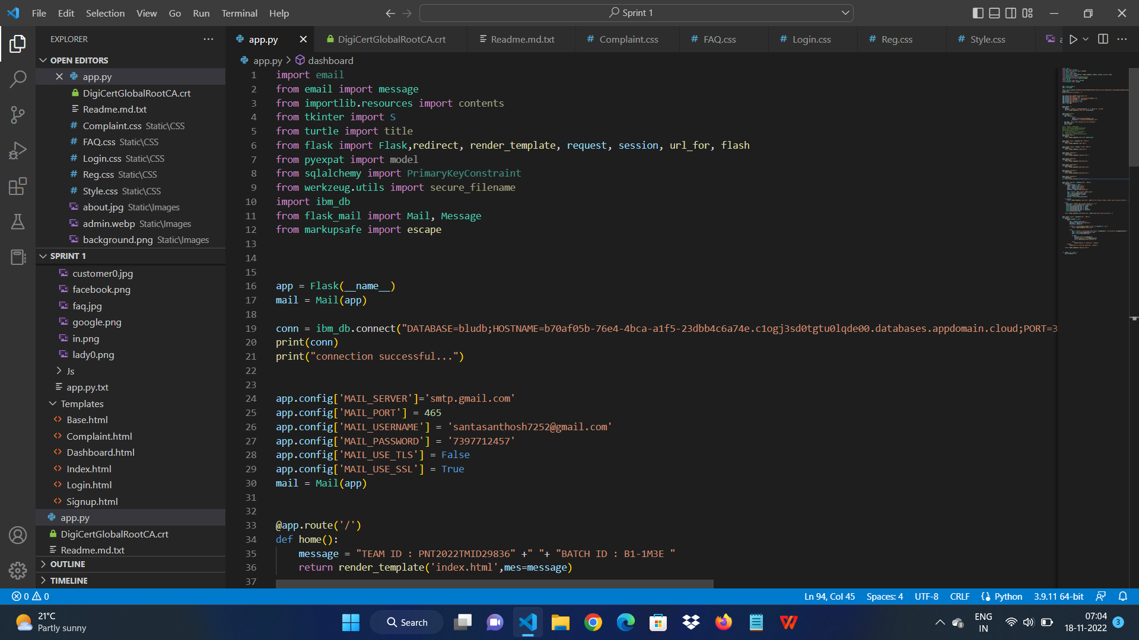

# OUTPUT:

IBM Cloud CLI is installed successfully